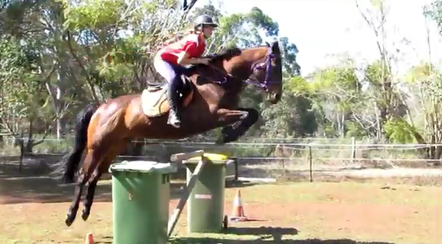
Chinga is For Sale

Thoroughbred, 8 year old, 16.2 hh

Great all rounder

He has done Show jumping, x country, eventing, dressage, sporting. You can ride him bareback and you can even double on him. You can stand on him.

He has Jumped 1.10 – 1.15 with potential to go higher
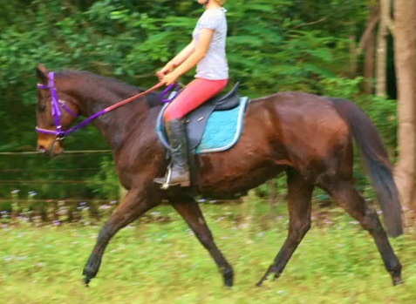

YouTube Clips

Snakes and Ladders
http://www.youtube.com/watch?v=hibQwWOBYAE&feature=channel

http://www.youtube.com/watch?v=3vJpoTAee-8&feature=channel

http://www.youtube.com/watch?v=0IYogEJLOyM&feature=channel

http://www.youtube.com/watch?v=hHkHiz4C6ps&feature=channel

http://www.youtube.com/watch?v=9y48xupZVyc&feature=channel

